Manage Talent card Configuration

Configure succession Talent Card:

Admin Center > Manage Talent Card

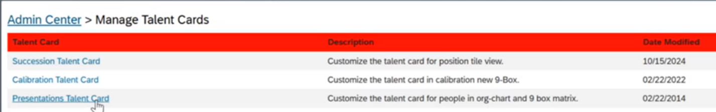

We do not use the Presentation talent Card
Succession talent Card : When you hover over you will be able to Edit / Delete or Move Up the Talent Card
To add a section, you can select add a section button and you will see the ones selected in there are already checked and greyed out

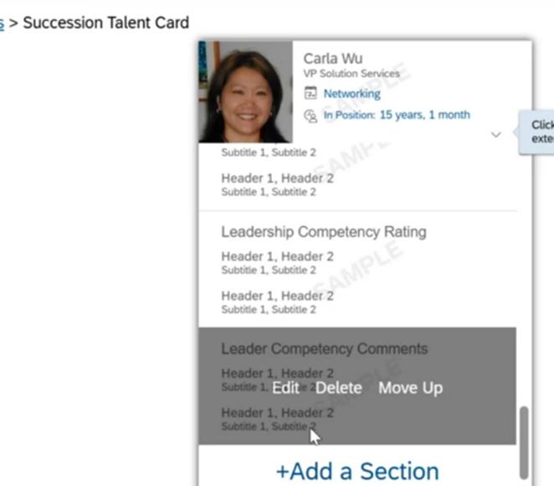

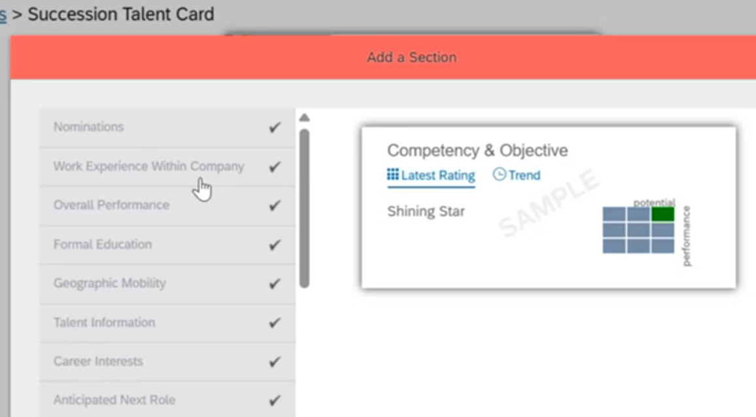

For example if we want to add Certification / Licenses, we will select that field

